PERFORMANCE AND TESTING

Date | 27-01-2026
Team ID | LTVIP2026TMIDS24894
Project Name | Educational Organization Using ServiceNow
Maximum Marks | 4 Marks

Model Performance Testing
User Creation
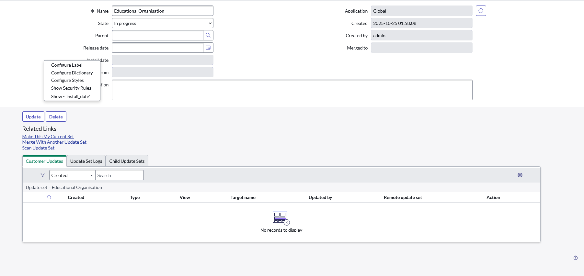

Assign Incident To User

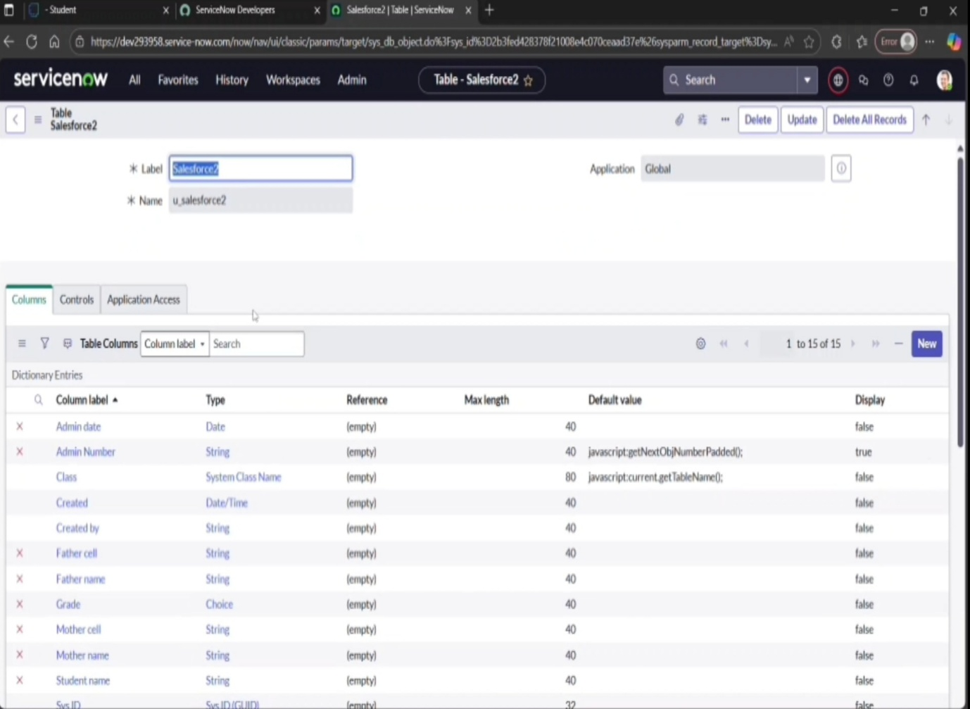

Business Rule Creation

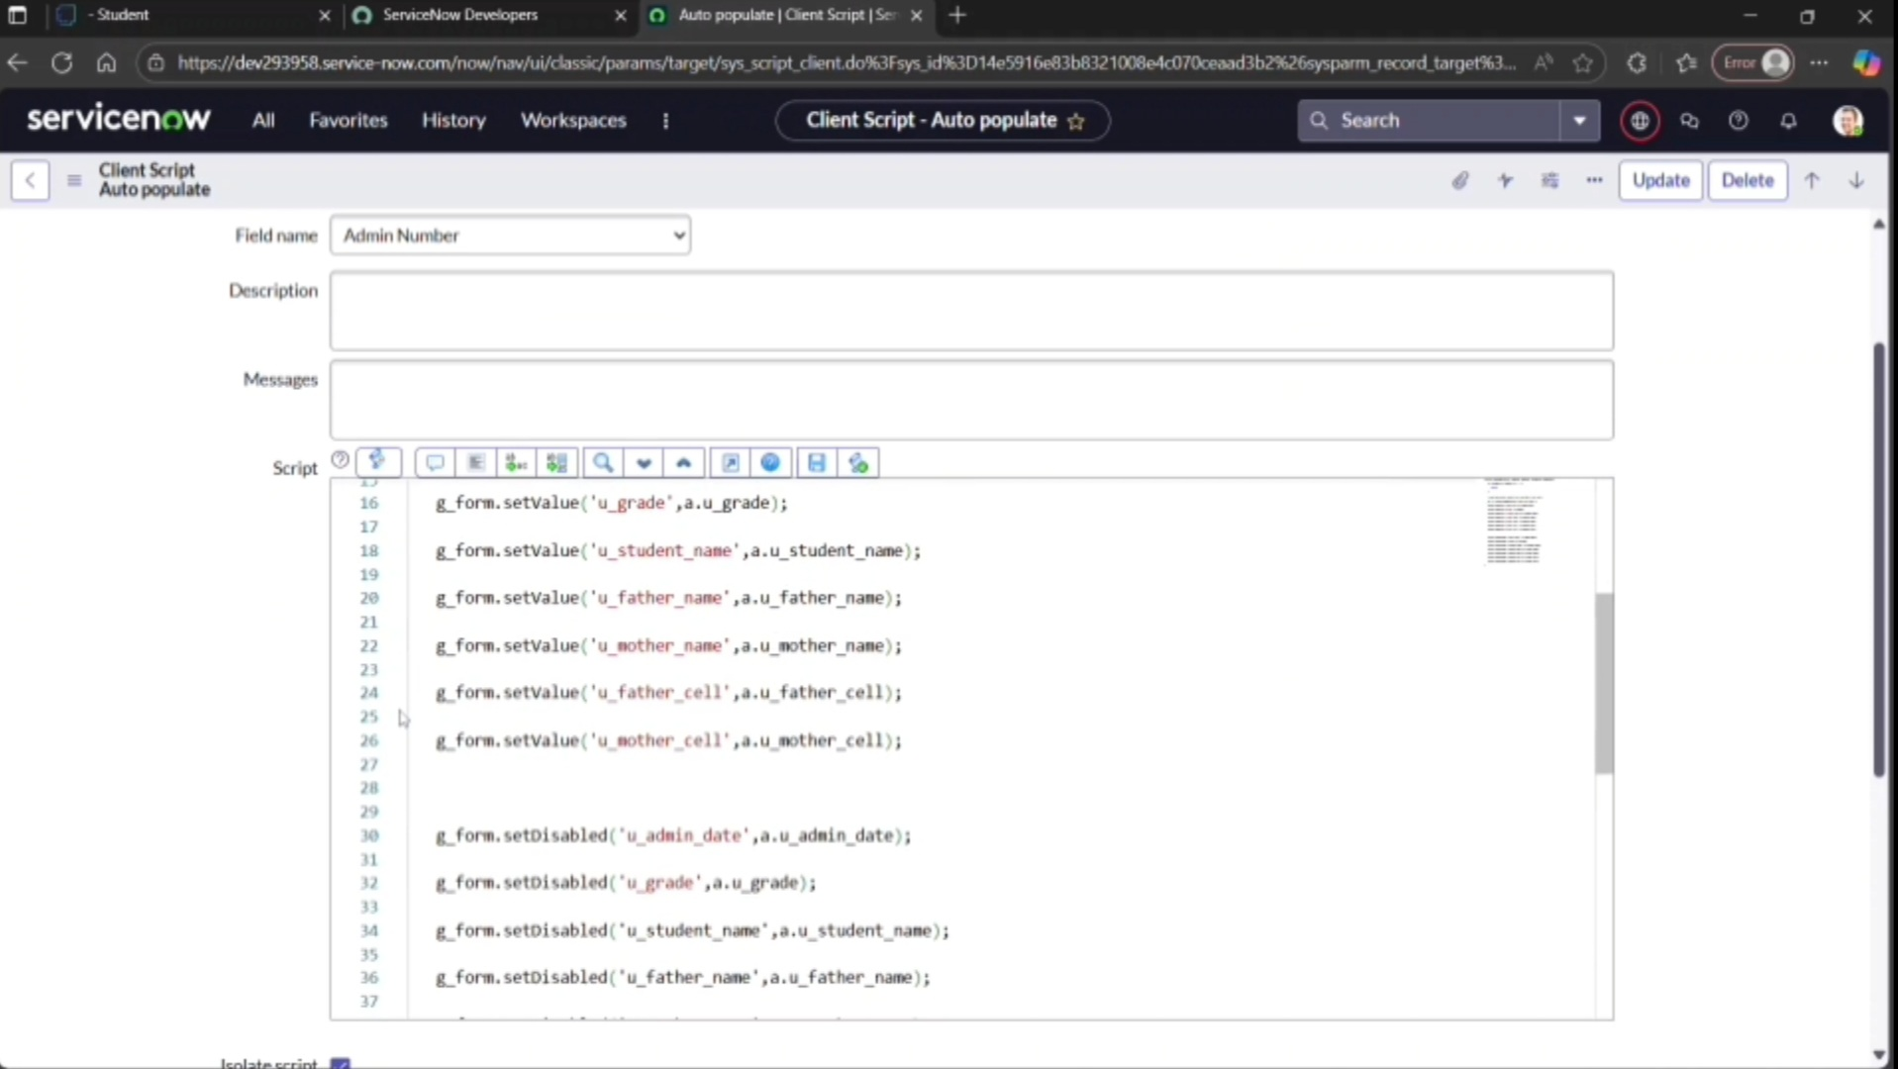

Test Deletion
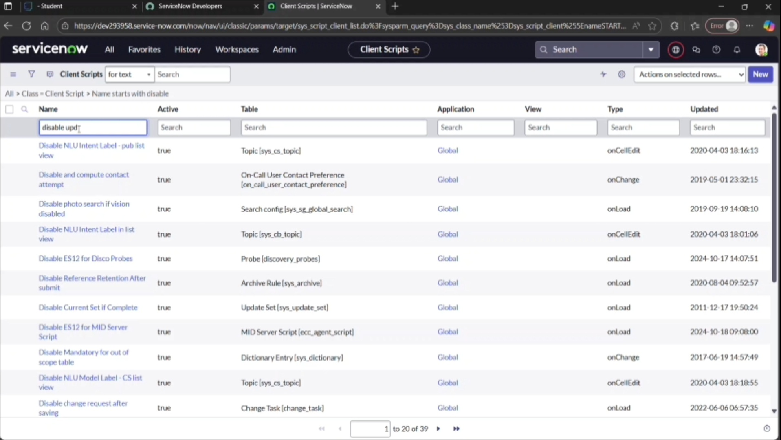

Test With Unassigned User

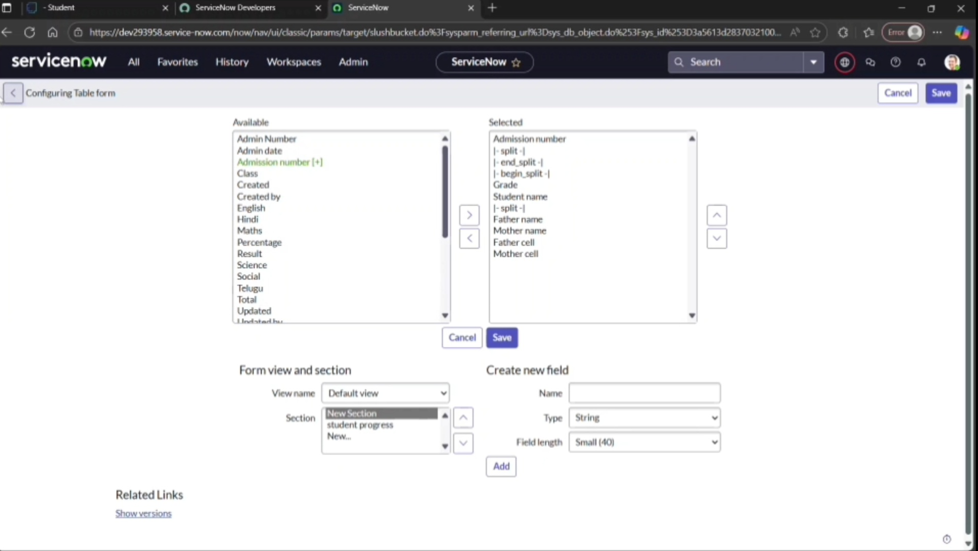
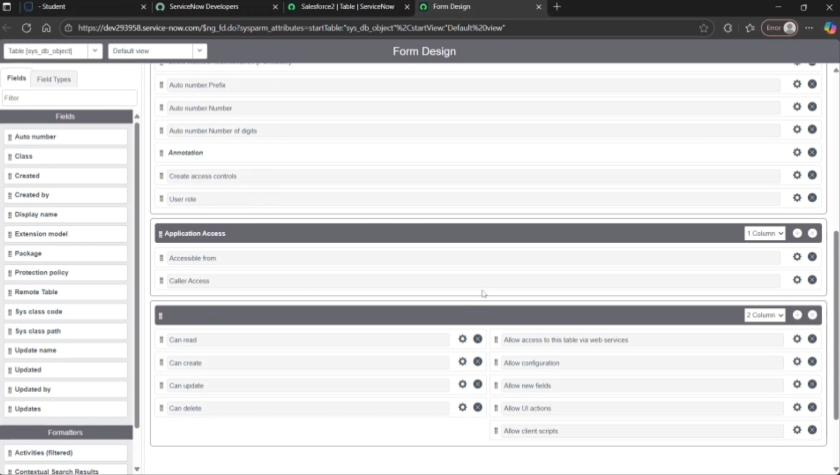
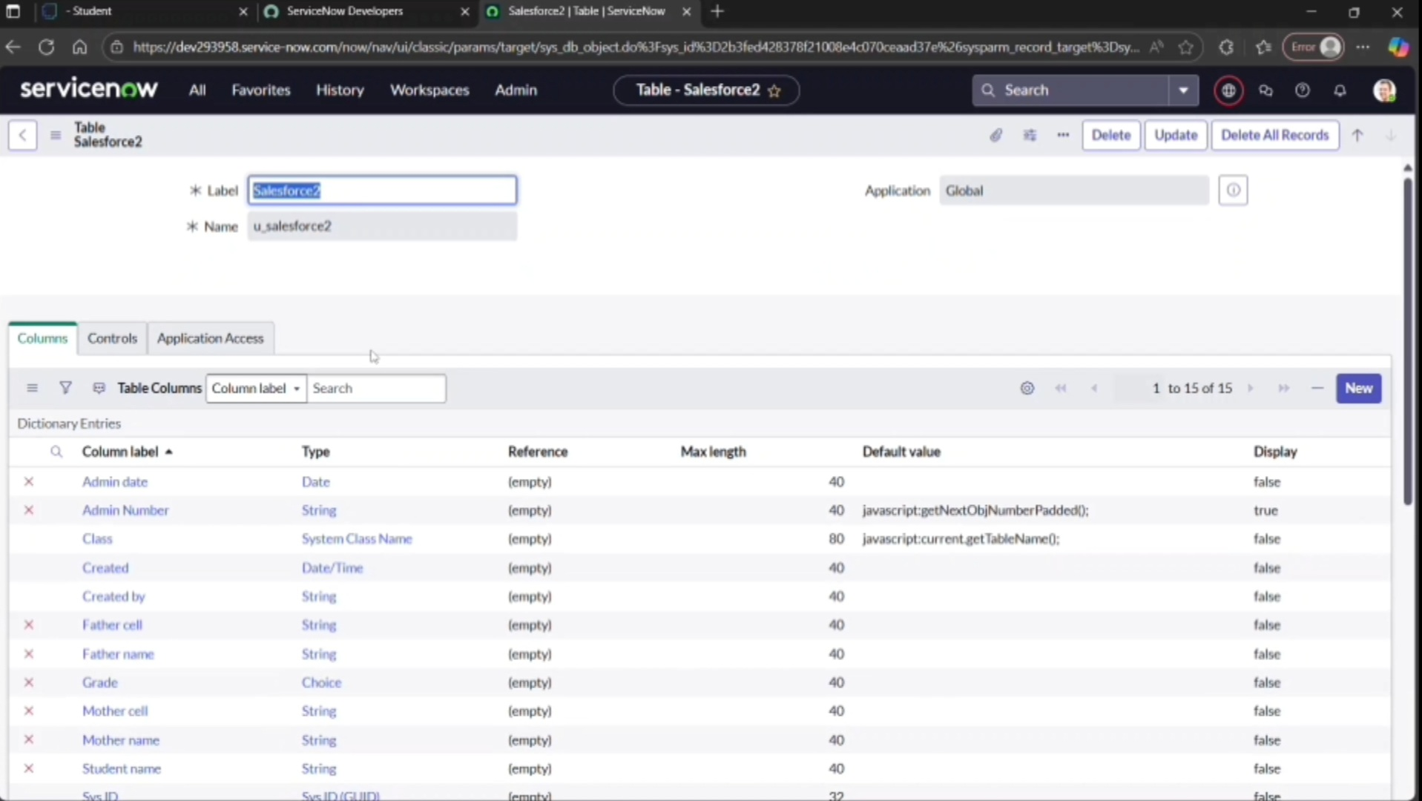

Parameters And Values
Explanation
- These parameters represent the key measurable and configurable elements used in your ServiceNow project.
- Each value can be customized based on your educational organization’s needs.
- Using these parameters ensures the system is flexible, scalable, and performance-oriented.

